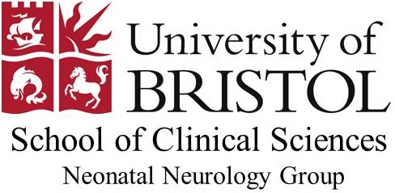   
**Programme**

**Perinatal Medicine and the newborn brain**

Date | Saturday 24th September 2016

Location | Chemistry Theatre, Cantock’s Close, Bristol BS8 ITS

Audience | Paediatric trainees, SAS and newly qualified & experienced consultants

|  |  |  |
| --- | --- | --- |
| 12:45 | *Registration* | |
| 13.00 | Welcome and Introduction & Chair Session 1:  Professor Andrew Wilkinson, Professor of Paediatrics and Perinatal Medicine, University of Oxford | |
| 13:10 | Neonatal Stroke | Frances Cowan, Honorary Clinical Senior Lecturer, Imperial College, London. Visiting Professor of Neonatal Neurology, University of Bristol |
| 13.35 | Intraventricular Haemorrhage and its complications | Linda de Vries, Professor of Neonatal Neurology, University of Utrecht, Netherlands |
| 14.00 | Developmental Interventions and outcome in preterm children | Neil Marlow, Professor of Neonatal Medicine, University College, London |
| 14.25 | Starting and stopping life support in the severely brain injured infant | John Wyatt, Professor of Ethics and Perinatology, University College London |
| 14.50 | How Cochrane changed the way we treat babies | David Evans, Consultant Neonatologist, Southmead Hospital, Bristol |
| 15.15 | *Break* | |
| 15.35 Chair Session 2:  Dr Karen Luyt, Senior Lecturer in Neonatal Medicine, University of Bristol | | |
| 15:40 | The metabolic and cardiovascular phenotype of the preterm adult. | Neena Modi, Professor of Neonatal Medicine, Imperial College, London. President of the Royal College of Paediatrics and Child Health |
| 16.05 | Ventriculo-peritoneal shunt surgery in newborn infants: how to reduce complications. | Kristian Aquilina, Consultant Neurosurgeon, Hospital for Sick Children, Great Ormond Street, London |
| 16.30 | Training and testing interventions in obstetric emergencies | Tim Draycott, Senior Clinical Lecturer in Social and Community Medicine, University of Bristol and Consultant Obstetrician, Southmead Hospital, Bristol |
| 16.55 | Connecting the fetal/infant brain in and out of the womb. | Hugo Lagercrantz, Professor of Paediatrics, Astrid Lindgren Children’s Hospital, Karolinska Institute, Stockholm, Sweden. Former President of the Swedish Pediatric Society and the European Society for Pediatric Research |
| 17.20 | *End of symposium* | |

## **CPCH has approved this activity for CPD in accordance with the current RCPCH CPD Guidelines. For attendees following a credits-based approach to CPD, this activity carries up to 3.5 CPD credits**

## **Chiesi are supporting the meeting through the purchase of exhibition stand space**.